**Mini-Tutorial on Creative Writing**

**Why Write Creatively?**

* to tell stories (small, big, or novel-sized!) or capture a moment in time
* to think through an issue (writing is a type of personal reflection *because* you think about an issue as you write it)
* to escape the ordinary and exercise your imagination (the sky is the limit!)
* to write song lyrics, stories, poetry, life events, books, novels, short stories, etc.

**How Do I Start?**

* Determine a way to write that works best for you: Is it by hand? On a keyboard? On a tablet? Which is the most comfortable?
* Arrange a comfortable writing environment (want music? something to drink? Do you have a comfortable place to sit and work?)
* **Pre-Writing or Pre-Planning**

**Pre-Writing / Pre-Planning**

These are a few suggestions about starting to write creatively and exploring your ideas further. Don’t worry about how messy you get!

* **Free Writing/Stream of consciousness writing:** This is a good way to start if you already have an idea. Free writing consists of exploring an idea by stating it in writing and adding all the different directions you think of that involve that idea. As you write, don’t worry about ordering words, sentences, spelling, or punctuation; just let words, thoughts, and phrases flow. The most important part of this process is simply getting the whole swirl of details in your head where you can see them. Put a time limit on free writing “sessions” to ensure you focus on and explore just one subject. Free writing is not meant to be pretty, but it can be useful in developing or exploring ideas.
* **Brainstorming**: This is another way to develop ideas. Pick words, ideas, or concepts, and consider how they can be expanded. This is similar to mind-mapping, but has no firm rules: there is no limit to brainstorming except how far we push ourselves. A good rule is to think of three ideas from one concept, and explore each idea as thoroughly as possible. When you feel you’ve exhausted the idea, delete what will not work, and **explore further what will work**. The purpose of exploring ideas in this way is to consider all possibilities without limitations.



* **Shelling/Framing:** If you’ve decided on the basic concept or idea but aren’t sure how to attack it, write your idea on a page. Then arrange headings or questions you’d like answered, such as “I want to say …..”, “I want to show/illustrate that…”, “I will demonstrate this idea by….”, or other functional questions. Your details and responses will provide direction for your writing.
* **Journalistic Questions**: Take your idea and ask questions about it, such as “who” (who is involved?), “what?” (What happens or should happen?), “When?” (When does it occur, or must it occur?), “Why”? (Why is this important or significant?). Your responses will act as exploration and can help you with your planning.
* **Listing or Outlining:** Compose lists of ideas, topics, or subjects you wish to investigate. This is similar to mind-mapping but is a bit more linear. Find connections between lists, and make new lists putting the most relevant pieces of information together.
* **Mind-Mapping:** Find a starting point you’d like to explore further (an idea, concept, phrase or thought), and work your way out to explore its substance and see what can be connected to it.

**Planning *was* messy, but I clarified my ideas. Now What?**

**Ordering/Outlining**

* 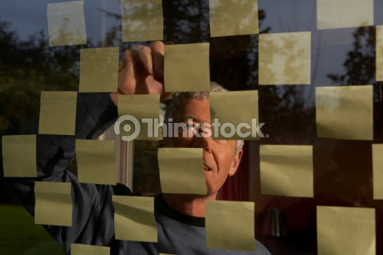Read your exploration notes, and put your information in the order you want it to be revealed or learned.
* Consider how you will reveal it. What viewpoint will you use? Will you use one or several characters? What’s the conflict? **How can you communicate your ideas in a story? What other choices about story elements will you make?**
* Once you’ve decided on essential story elements (and details addressing those elements), map events in a loose timeline. Following a timeline or outline will keep your writing on track. You can always return to it to see where you left off or still need to go.

**Okay, the process seems clear. Do I write now?**

Begin writing. Use your planning as a guide to refer to as you write; this will keep you on track. Keep these tips and tricks in mind as you write:



* Don’t worry about mistakes right away. If you write something you are unsure of, put a mark or note beside it and come back to it later. Editing as you write will slow your writing and may throw you off track.
* Keep a thesaurus nearby. Sometimes you might want to find a new way of saying something, or use a more precise word to describe something.
* Think about your audience—how will this sound to them when they read it? Consider carefully the effect your words will have on your audience. Do you want to make them pause and think, laugh, or smile? You can control these things with your written expression.
* You **do not** have to write in a certain order. If you have difficulty starting, you may want to write a different part first and later come back to the introduction. You can piece things together appropriately in a second draft.

**I’ve completed my first draft. What next?**

Now you will put some effort into making a polished copy. Apply the following steps to the first draft:

* Edit your work. Read it, looking for spelling mistakes and awkward-sounding sentences. Tweak everything you think will make it smoother and appealing.
* Check your order and ensure that the overall message makes sense. Have you achieved everything you wanted? Will your work impress your audience the way you originally hoped?
* After you’ve made all revisions, you have a polished copy. Hand it in!

